Marriage and Family Life Commission invites you to a FREE
Summer Family Day
Sunday 12th July 2026

Location: Parish Centre, Stella Maris, 2 Saint Mary's Road,
LL30 2UB, Llandudno
(Hall for Our Lady Star of the Sea Church in Llandudno)
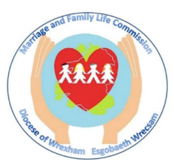
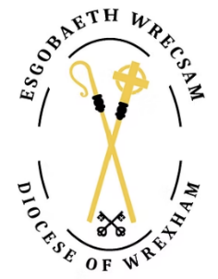
Time 13:00 – 17:30
Please, bring a picnic lunch.
Refreshments provided.
Everyone is welcome
crafts and activities for all ages
16:30 Family Mass led by Bishop Peter
Musicians and young musicians are most welcome to join us in playing or singing the music for the Mass, please let us know as soon as possible
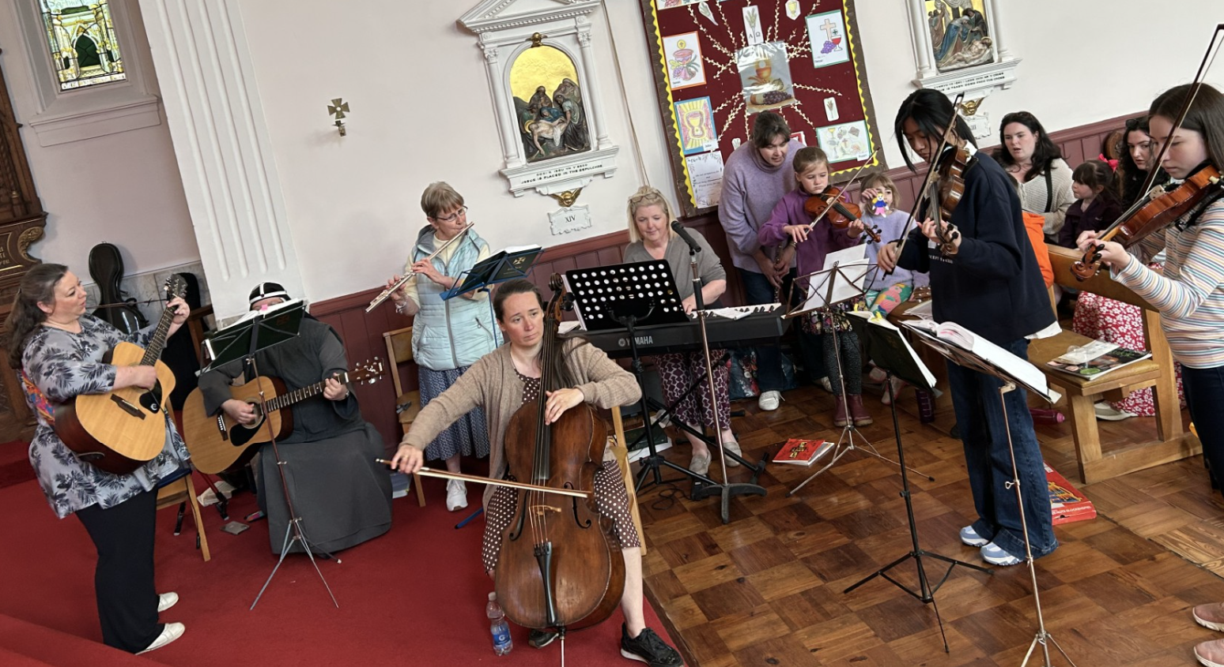


Limited spaces available. Booking is essential via QR Code If you have any questions or would you like to help on the day please contact Wioletta Trebska
Marriage and Family Life Worker
mfl@rcdwxm.org.uk or 07542 268728

